The Islamia University of Bahawalpur
Department of Information Technology Faculty of Computing

SYSTEM DESIGN DOCUMENT (SDD)
for
E - Voting
Version 1.0
By
Muhammad Naeem
F22BINFT1M01067
5M
Session Fall 2022– 2026
Supervisor
Ms. Sara Farid
Bachelor of Science in Information Technology
Revision History
Name | Date Reason for changes | Version

Document Approval
The following Software Requirements Specification has been accepted and approved by the following:
Signature | Printed Name Title | Date

Application Evaluation History
Comments (by committee)
Action Taken
*include the ones given at scope time both in doc and
presentation

Supervised by
Ms. Sara Farid
Signature______ _____
E - VOTING SYSTEM
Page Index
ABSTRACT………………………………………………………………………...........1 1.
INTRODUCTION…………………………………………………………………….2-3
2.
ANALYSIS……………………………………………………………………………..4-5
3. FEASIBILITY
STUDY………………………………………………………………...6-9 4. DESIGN……………………………………………………………………………….10-20 5. SYSTEM MODELING……………………………………………………………… 21-26
CONCLUSION…………………………………………………………………………… 27
Table Index
1. DATABASE TABLE…………………………………………………………………26 1.1 ADMIN TABLE…………………………………………………………………...26 1.2 VOTER INFORMATION DATA TABLE………………………………………26 Figure Index
COMMUNICATION INTERFACE…………………………………………………15 DATA FLOW DIAGRAMS…………………………………………………………..17 DFD: LEVEL 0………………………………………………………………………17 DFD: LEVEL 1……………………………………………………………………….18 DFD: LEVEL 2……………………………………………………………………….19 ER DIAGRAMS
CLASS DIAGRAM
ABSTRACT
Resources Required:-
Development Tool:- Python
Database- MySql
INTRODUCTION-:
“e -voting” is an online voting technique. It is based on the other online services like “ONLINE RESERVATION SYSTEM” .In this system people who have citizenship of Pakistan and whose age is above 18 years of any sex can give his\her vote online without going to any polling booth. There is a DATABASE which is maintained by the ELECTION COMMISION OF Pakistan in which all the names of voters with complete information is stored.
SCOPE-:
⮚ This system will increase the voting percentage in Pakistan.
⮚ If high security is applied then it may reduce false vote.
WORKING-:
In “e -voting” a voter can use his\her voting right online without any difficulty. He\She has to fill a registration form to register himself\herself. All the entries is
checked by the DATABASE which has already all information about the voter. If all the entries are correct then a Voter ID and PASSWORD is given to the voter, by using that ID and PASSWORD he\she can use his\her vote. If conditions are wrong then that entry will be discarded.
INTRODUCTION
1.1 Purpose
In “e -voting” a voter can use his\her voting right online without any difficulty. He\She has to fill a registration form to register himself\herself. All the entries are checked by the DATABASE which already has all information about the voter. If all the entries are correct then a Voter ID and PASSWORD is given to the voter, by using that ID and PASSWORD he\she can use his\her vote. If conditions are wrong then that entry will be discarded.
1.2 Scope
The scope of the project that is hosted on the server. There is a DATABASE which is maintained by the ELECTION COMMISION OF Pakistan in which all the names of voters with complete information are stored.
1.3 Technologies to be used
This project will be a Web application to be developed in Python having
∙ Database Design (My SQL)
∙ Form Design (HTML 4.0)
∙ Coding (Python)
∙ Testing (WAMP SERVER)
∙ Reporting Tool (Data Report)
1.4 Overview
✔ Project is related to e -voting.
✔ The project maintains two levels of Voters:-
∙ Administrator Level
∙ Voter Level
✔ Main facilities available in this project are:-
∙ Maintaining voter’s Identification.
∙ Providing online voting management.
∙ Providing Updation of voter’s information.
∙ Provide voter information to the ELECTION COMMISION OF Pakistan.
∙ ELECTION COMMISION OF Pakistan maintains the complete information of voters.
∙ Voters can give his\her vote from any part of Pakistan.
OVERALL DESCRIPTION
2.1 Goals of proposed system
1. Planned approach towards working: - The working in the organization will be well planned and organized. The data will be stored properly in data stores, which will help in retrieval of
information as well as its storage.
2. Accuracy: - The level of accuracy in the proposed system will be higher. All operations would be done correctly and it ensures that whatever information is coming from the center is accurate. 3. Reliability: - The reliability of the proposed system will be high due to the above stated reasons. The reason for the increased reliability of the system is that now there would be proper storage of information.
4. No Redundancy: - In the proposed system utmost care would be that no information is repeated anywhere, in storage or otherwise. This would assure economic use of storage space and consistency in the data stored.
5. Immediate retrieval of information: - The main objective of the proposed system is to provide for a quick and efficient retrieval of information.
6. Immediate storage of information: - In manual systems there are many problems with storing the largest amount of information.
7. Easy to Operate: - The system should be easy to operate and should be such that it can be developed within a short period of time and fit in the limited budget of the Voter.
2.2 Background
e -voting is a voting system by which any Voter can use his\her voting rights from anywhere in Pakistan. e -voting contains-:
∙ Voter’s information in the database.
∙ Voter’s Names with ID.
∙ Voter’s vote in a database.
∙ Calculation of total number of votes.
Various operational works that are done in the system are:-
∙ Recording information of the Voter in the Voter database.
∙ Checking information filled by voter.
∙ Discard the false information.
∙ Each information is sent to the ELECTION COMMISSION OF Pakistan.
2.3 Project Requirements
Hardware Requirements (Processor RAM Disk Space)
Pentium II, Pentium III, Pentium IV, Higher 128 Mb or Higher 130 Mb
Software Requirements (Operating System Database)
Win-98, Win-XP, Linux, My SQL
2.4 Voter Characteristics
Every Voter should be:
✔ Comfortable with Internet Browsers.
✔ He must have a brief knowledge of voting system.
✔ He must also have basic knowledge of English too.
2.5 Constraints
✔ GUI is only in English.
✔ Login and password is used for identification of voters.
2.6 Definitions of problems
• Not Voter Friendly: The existing system is not Voter friendly because the retrieval of data is very slow and data is not maintained efficiently.
• Difficulty in report generating: We require more calculations to generate the final result so it is generated at the end of the session. And the voter does not get a single chance to change his\her vote.
• Time consuming: Every work is done manually so we cannot generate reports in the middle of the session or as per the requirement because it is very time consuming.
FEASIBILITY STUDY
Depending on the results of the initial investigation the survey is now expanded to a more detailed feasibility study. “FEASIBILITY STUDY” is a test of system proposal according to its workability, impact of the organization, ability to meet needs and effective use of the resources. It focuses on these major questions:
1. What are the Voter’s demonstrable needs and how does a candidate system meet them? 2. What resources are available for a given candidate system?
3. What are the likely impacts of the candidate system on the organization? 4. Is it worth solving the problem?
During feasibility analysis for this project, following primary areas of interest are to be considered. Investigation and generating ideas about a new system does this.
Steps in feasibility analysis
Eight steps involved in the feasibility analysis are:
∙ Form a project team and appoint a project leader.
∙ Prepare system flowcharts.
∙ Enumerate potential proposed systems.
∙ Define and identify characteristics of the proposed system.
∙ Determine and evaluate performance and cost effectiveness of each proposed system. ∙ Weight system performance and cost data.
∙ Select the best-proposed system.
∙ Prepare and report the final project directive to management.
3.1 Technical feasibility
A study of resource availability that may affect the ability to achieve an acceptable system. This evaluation determines whether the technology needed for the proposed system is available or not. ∙ Can the work for the project be done with current equipment, existing software technology & available personnel?
∙ Can the system be upgraded if developed?
∙ If new technology is needed then what can be developed?
∙
∙ This is concerned with specifying equipment and software that will successfully satisfy the Voter requirement. The technical needs of the system may include:
Front-end and back-end selection
An important issue for the development of a project is the selection of suitable front-end and back end. When we decided to develop the project we went through an extensive study to determine the most suitable platform that suits the needs of the organization as well as helps in development of the project.
The aspects of our study included the following factors.
Front-end selection:
1. It must have a GUI that assists employees that are not from IT
background. 2. Scalability and extensibility.
3. Flexibility.
4. Robustness.
5. According to the organization requirement and the culture.
6. Must provide excellent reporting features with good printing support.
7. Platform independent.
8. Easy to debug and maintain.
9. Event driven programming facility.
10. Front end must support some popular back end like Ms Access.
According to the above stated features we selected Python as the front-end
for developing our project.
Back-end Selection:
1. Multiple Voter support.
2. Efficient data handling.
3. Provide inherent features for security.
4. Efficient data retrieval and maintenance.
5. Stored procedures.
6. Popularity.
7. Operating System compatible.
8. Easy to install.
9. Various drivers must be available.
10. Easy to implant with the Front-end.
According to the above stated features we selected MY SQL as the backend.
Technical feasibility is frequently the most difficult area encountered at this stage. It is essential that the process of analysis and definition be conducted in parallel with an assessment to technical feasibility. It centers on the existing computer system and to what extent it can support the proposed system.
3.2 Economical feasibility
Economic justification is generally the “Bottom Line” consideration for most systems. Economic justification includes a broad range of concerns that includes cost benefit analysis. In this we weigh the cost and the benefits associated with the candidate system and if it suits the basic purpose of the organization i.e. profit making, the project is made to the analysis and design phase.
The financial and the economic questions during the preliminary investigation are verified to estimate the following:
∙ The cost to conduct a full system investigation.
∙ The cost of hardware and software for the class of application being considered. . The benefits in the form of reduced cost.
∙ The proposed system will give the minute information, as a result the
performance is improved
∙ This feasibility checks whether the system can be developed with the available funds. The e -voting does not require an enormous amount of money to be developed. This can be done economically if planned judicially, so it is economically feasible. The cost of the project depends upon the number of man-hours required.
3.3 Operational Feasibility
It is mainly related to human organizations and political aspects. The points to be considered are:
∙ What changes will be brought with the system?
∙ What organization structures are disturbed?
∙ What new skills will be required? Do the existing staff members have these skills? If not, can they be trained in due course of time?
The system is operationally feasible as it is very easy for the End Voters to operate it. It only needs basic information about the Windows platform.
3.4 Schedule feasibility
Time evaluation is the most important consideration in the development of a project. The time schedule required for the development of this project is very important since more development time affects machine time, cost and causes delay in the development of other systems. A reliable e -voting can be developed in the considerable amount of time
DESIGN
4.1 Software Requirement Specification
4.1.1 Objective:
The main objectives of system for e -voting are:
∙ The objective of e -voting is to help the organization in automating the whole manual processing of the existing system.
∙ The main objective to develop the system is to make accurate & efficient decisions in different tasks at different times in different situations. The existing system is manual so members of the unit generally face a lot of embarrassing situations many times. Now they need to automate the whole process so as to make it more easy and accurate.
∙ System should support a multi-Voter environment.
∙ System should be fully automated.
∙ System should provide concrete security features like creating Voters and assigning privileges to Voters of the system.
∙ System should be capable of keeping track of all the detailed descriptions of the client and the whole details of services offered by the client organization.
∙ Various outputs (reports) should be available online any time.
∙ System should be able to handle extremely large volumes of data (i.e. Large database support)
4.1.2 Scope:-
1. Advanced technology- It is an advanced technology used nowadays. It increases the E knowledge of the Voters which is very necessary for the current generation.
2. Internet: It is an online facility and hence very useful for the Voters.
Voters can vote from anywhere at any time in Pakistan.
3. E-Mails: ELECTION COMMISION OF Pakistan can send the error report to a particular Voter if he\she entered false information.
4. E-SMS: People who have no internet connection can not check the emails or not have email they can be informed by SMS on their mobile. Today many websites provide free SMS to the mobile. ELECTION COMMISION OF Pakistan can use these to send any information.
4.1.3 Advantages:
∙ Fast and easy service.
∙ The e -voting is less time consuming .
∙ It reduces the paper work and makes the work less tedious for ELECTION COMMISION.
∙ It is a better way to voting.
∙ By this voting percentage will increase drastically.
Voters have no need to go to any polling booth ,so it is easy to use.
4.1.4 Technologies to be used:-
This project will be a Web application to be developed in Python having ∙ Database Design (My SQL)
∙ Form Design (HTML 4.0)
∙ Coding (Python)
∙ Testing (Django server SERVER)
∙ Reporting Tool (Data Report)
4.1.5 OVERVIEW:
1. Requirements:
• FUNCTIONAL REQUIREMENTS:
∙ Registration of the voter is done by ELECTION COMMISION OF Pakistan. ∙ ELECTION COMMISION OF Pakistan can change the information any time if required. ∙ Registration of the Voter depends upon the information filled by the Voter. ∙ Voters are given a unique ID and PASSWORD.
Voters can vote after login and entering the ID and PASSWORD. ∙
∙ In the DATABASE information of every voter is stored.
∙
∙ Database shows the information of every Voter.
• NON-FUNCTIONAL REQUIREMENTS:
1. Secure access of confidential data (Voter’s details). SSL can be used. 2. 24 X 7 availability.
3. Better component design to get better performance at peak time.
4. Flexible service based architecture will be highly desirable for future extension 2. Project Requirements
Hardware Requirements (Processor RAM Disk Space)
Pentium II, Pentium III, Pentium IV, Higher 64 Mb or Higher 130 Mb
Software Requirements (Operating System Database)
Win-98, Win-XP, Linux, My SQL
3. Software interface:
• Client on Internet: Web Browser, Operating System (Windows).
. Client on intranet: Client Software, Web Browser, Operating System (Windows). •
Web Server: WAMP Server, Operating System (Windows)
• Database server: MYSQL, Operating System (Windows).
4. Communication interface:
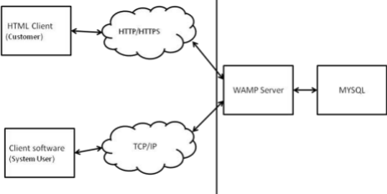HTML Client
Client side Application server Database server
The above diagram shows the connectivity between the client side, application server and database server. The client or customer can access the HTML server or client software. These are connected to the Wamp Server (WAMP) by a TCP/IP which is a communication protocol used to connect the teachers or parents to the internet. This WAMP Server now directly communicates with the database made in MYSQL. All the enquiries or data will be retrieved from the database.
4.1.6 Summary:
“e -voting” is an online voting technique. It is based on the other online services like “ONLINE RESERVATION SYSTEM” .In this system people who have citizenship of Pakistan and whose age is above 18 years of any sex can give his\her vote online without going to any polling booth. There is a DATABASE which is maintained by the ELECTION COMMISION OF Pakistan in which all the names of voters with complete information are stored.
In “e -voting” a voter can use his\her voting right online without any difficulty. He\She has to fill a registration form to register himself\herself. All the entries are checked by the DATABASE which already has all the information about the voter. If all the entries are correct then a Voter ID and PASSWORD is given to the voter, by using that ID and PASSWORD he\she can use his\her vote. If conditions are wrong then that entry will be discarded.
4.2 Data Flow Diagram DFD: Level 0
Voter
or
Administrator
Output
System
DFD Level-0
The above diagram is a 0-level DFD that only shows the flow of data between the various and the system. In e -voting the Administrator is the controller of the system and all the decisions are made by him. The Administrator can handle the entire voter and their details, voting details etc. and view details of them and he can update that detail also.
DFD: Level 1:-
Login
Process
Voter
information
checking
process
Voting
Process DFD Level 1
Final
Report
Voter
Registration
Process
The above shown diagram is a 1-level Data Flow Diagram for the e -voting. According to this DFD various processes are done after the login process. The Administrator can register voters. The ELECTION COMMISION can register the voters and voters can use their voting rights. The voter can view the final report after giving a vote..
.
DFD: Level 2
2.1:-
Administrator Voter Login Process
Login
Voter
Registration Information checking
Voting process Final Result
voter data stored data voting data final result _{administrators}ElectionCommission
DFD: Level 2.1
The above shown diagram is a 2.1 level Data Flow Diagram for the Online voting system. According to this DFD. The Administrator can register the voter information. Administrators can allow or deny the voter. A voter can vote if all the information filled by him\her is correct.
SYSTEM MODELING
Entity Relationship Diagram
Admin.
Voting Report
Fail
VOTING
Fig.- E-R Diagram
Registration
VOTER
id^{Pass} Login
Report View
The entity relationship diagram shows the relationship between the various Voters and their attributes. There is a relationship between the election commission and voter. The VOTER has different attributes to store their data to the database are as follows:- 1. Name-Name contain first name, middle name, last name.
2. Age (should be above 18 years)
3. City
4. State
5. Father’s/Husband Name
6. Address
7. Phone number (Permanent)
8. Phone number (Mobile)
9. Email address
Class diagram-:
Fig: Relationship between the interface Actor List and its inheriting classes Fig: Association between Actor interface and other inheriting classes Registration, login, and logoff modules act as mediator.
Fig: Association between Registration, Actor List, Login, Logoff Fig: Association between Election and Ballot (Flyweight,
Singleton) Database Tables:-
Admin Table:-
S. No. Field Name | Data Type Description
1. Login id | Varchar Login id for Admin.(Primary key)
2. Password | Varchar Password for Login
3. Name | Varchar Name of the Administrator

Voter information Data Table:-
S. No. Field Name | Data Type Description
1. Login id | Varchar Login id for Voter(Primary key)

2. Password | Varchar Password for Login

3. Name | Varchar Name of the voter
4. Father’s/Husband name | Varchar Voter’s father or  husband name
5. House no. | Varchar House no. of voter
6. Address | Varchar Address of voter
7. City | Varchar City of voter
8. Mobile | Varchar Mobile No of voter
9. E-Mail | Varchar E-Mail of voter

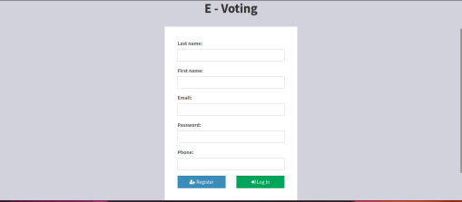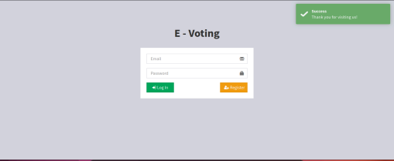
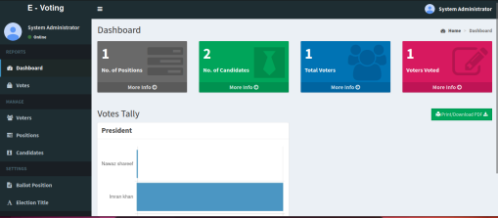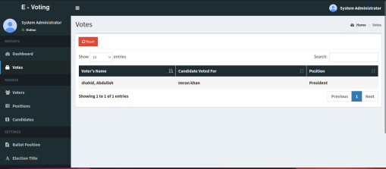
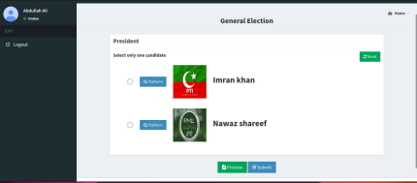CONCLUSION
This e -voting will manage the Voter’s information by which the voter can login and use his voting rights. The system will incorporate all features of the Voting system. It provides the tools for maintaining voter’s vote to every party and it counts total no. of votes of every party. There is a DATABASE which is maintained by the ELECTION COMMISION OF Pakistan in which all the names of voters with complete information are stored.
A Voter who is above 18 year’s registers his/her information on the database and when he/she wants to vote he/she has to login by his id and password and can vote to any party only single time. Voting details are stored in the database and the result is displayed by calculation. By online voting system the percentage of voting is increased. It decreases the cost and time of the voting process. It is very easy to use and It is very less time consuming. It is very easy to debug.

